CURRICULUM VITAE
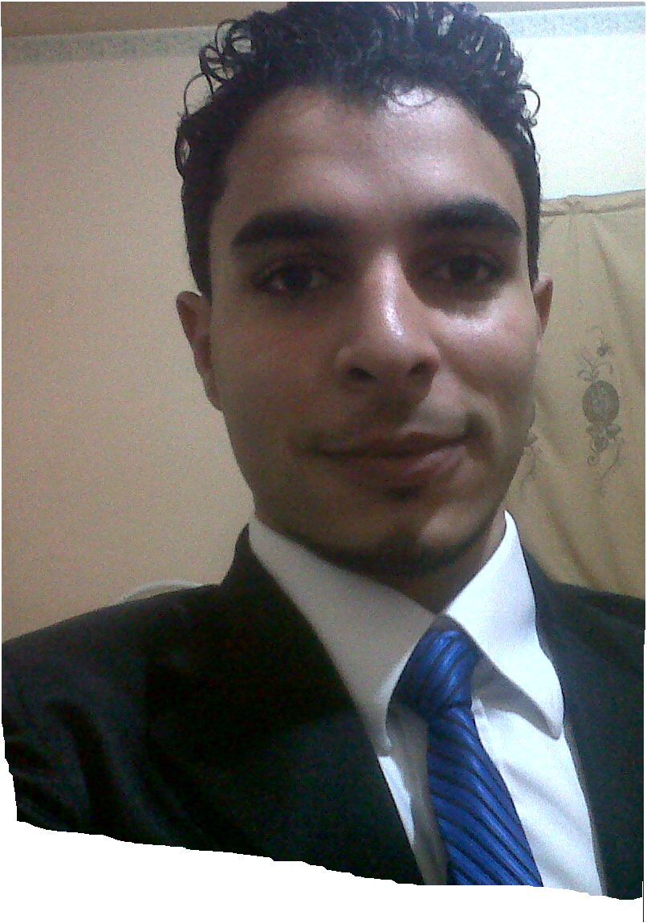

- Personal Profile

Name : Ali Hussain Ali

Date of Birth : 21-03-1990

Gender : Male

Marital Status : Marid

Nationality : Bahraini

CPR NO : 900207566
Contact NO : 66331500, 66330477
E mail : ali.hussain.ali@hotmail.com
- Objectives

To pursue my career through a professionally competitive environment in a progressive organization offering the opportunity to fully utilize and contribute the best of my abilities in the interest of the organization.

- Strengths

- Knowledge of accounting matters.
- Supervision of the workers, and to the workflow.
- Perform the functions of public relations.
- Customer Service.
- Management of the procurement process.

- Personal Skills

- Ability to work with large number of tasks.

- Ability to deal with people diplomatically.

- Ability to learn quickly and adapt to changing environment.

- Willing to shoulder challenges and responsibilities.

- Time management and team work.

- Excellent communication skills.

- Academic Chronicle

- Higher National Diploma (HND) IN Engineering Networking from Sheikh Khalifa bin Salman Institute, the curriculum and the certificate of Scotland .

- Successfully completed secondary Certificate from AL Jabriya Secondary Technical school , Specialty electrician .

- Organization Profile

- Nature of Work
Profession | Director of the establishment
Present Employer | AL Hoot for renting building material and contracting
Present Employer | Bahrain Aluminium extrusion company
Experiences | Start on :  ( 1st May 2006 onwards)
Experiences | Start on :  (1st December onwards)

Accounts
Bookkeeping calculations, issuing and receiving invoices, checks and cash.
Public Relation
Do all the work of the institution with the official authorities, banks and institutional partners, and customers of the permanent : institutions, ministries and companies.
Public Administration
Follow-up of staff and allocation of functions and tasks to them and supervise the progress of work.
- Nature of Work

Pushing aluminium section and s.opreter in press and opretor in saw machin ,programmer,enter data,supervisor.

- Languages Known

- Arabic , English and Hindi

- Computer Knowledge

- The ability to write quickly on the computer in both Arabic and English.
- Good dealing with Microsoft programs 2003 & 2007 and Good dealing at Windows XP and Windows Vista .

- Hobbies

- Reading motivating books & Listening Music.
- Surfing Net.
- Playing football.
- Participating in social work
Observation:
- I have GOOD CONDUCT CERTIFICATE from Ministry of Interior .

